I created and switched between branches, committed changes on a feature branch, merged the feature branch into main, resolved a merge conflict in README.md, cleaned untracked files, and finalized the repository with a clean working tree.

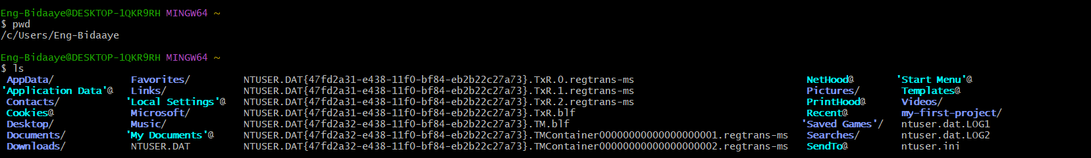

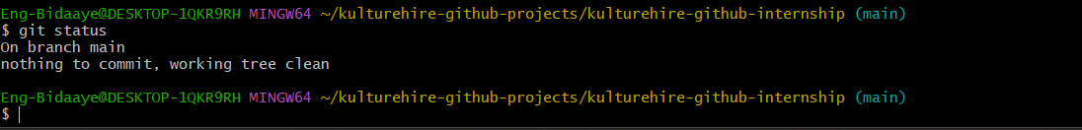
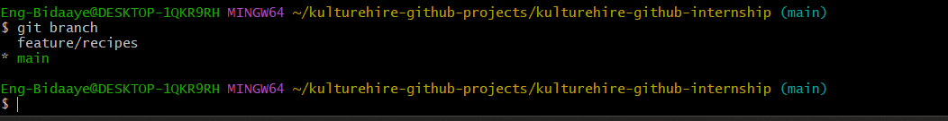
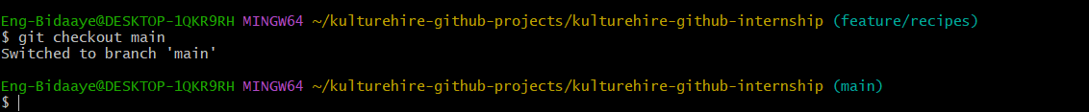
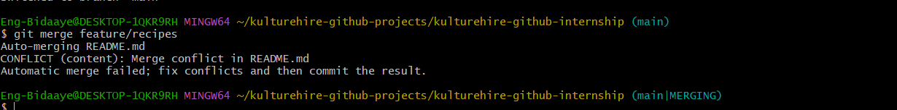
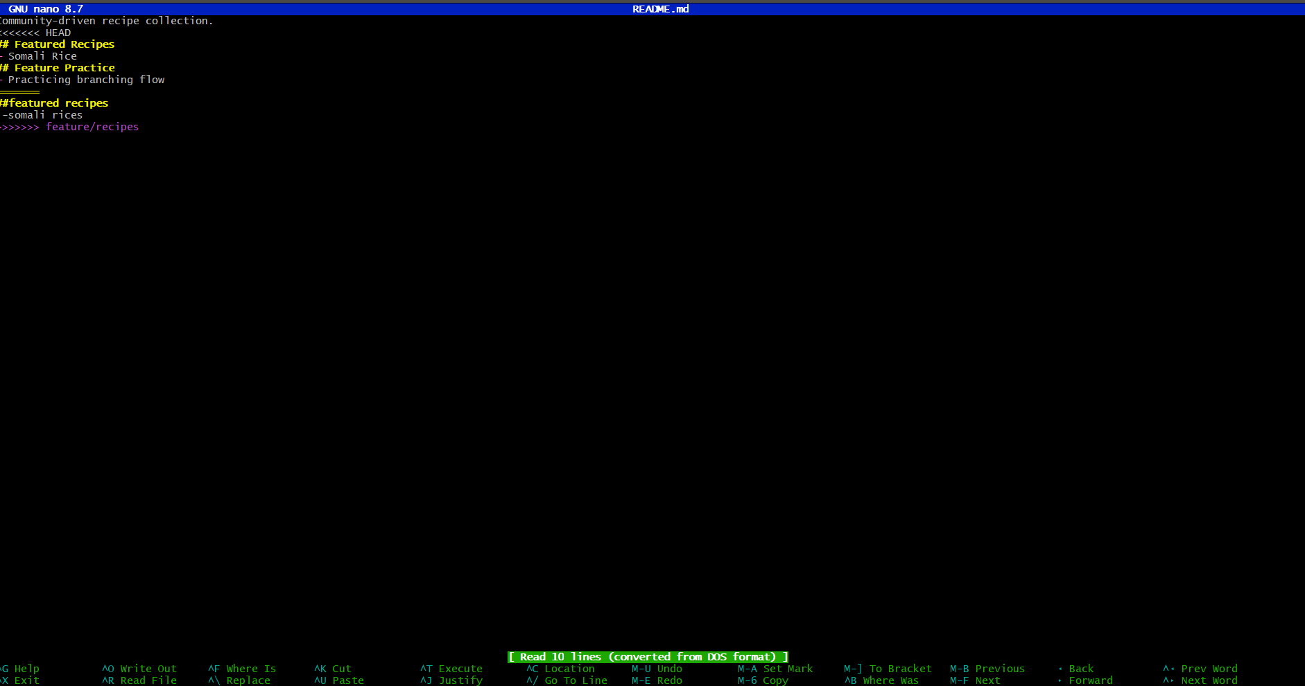
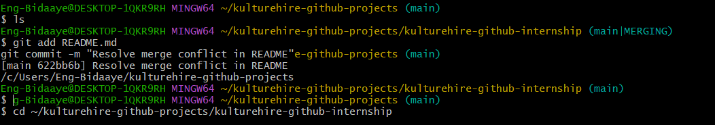
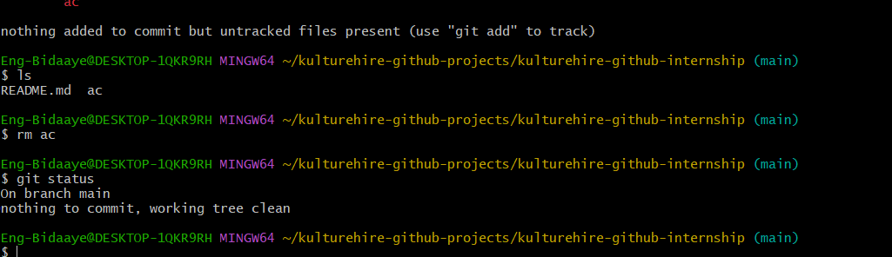
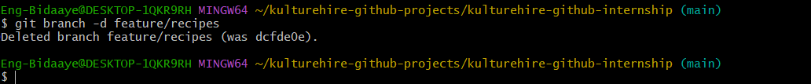
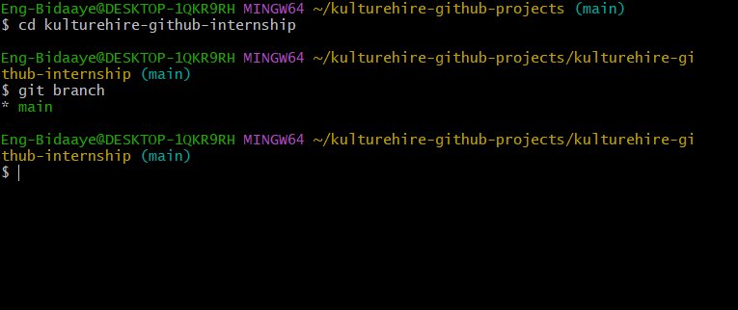
Here is my link
https://github.com/Eng-Bidaaye/kulturehire-github-internship

